**Is Public Speaking the Kryptonite of Data Scientists?**

**The three key lessons that helped me improve my presentation skills**

Almost seven years ago, during my Master’s degree, I was one of the three students selected to work in collaboration with South East Water. The deal was that the company would give me data from their meters, which I would then use as the basis for my thesis analysis. But there was a catch! I also had to prepare a deck with the insights of my thesis and present it live to an audience of 10 stakeholders.

Even though I now realize this was a great opportunity to practice my presentation skills and enhance my CV, it did not feel that way back then. This would be my first presentation in a business setting, and in my mind I knew with almost absolute certainty that not only I would be very nervous, but probably they would also ask me questions that would showcase my lack of experience as an analyst (my first stab at imposter syndrome).

Since then, I have devoted much time to improving my presentation skills. I presented more than 300 times to business stakeholders and in training sessions. More recently, I also had the opportunity to present live at Imperial’s Data Science Research Industry Showcase and my company’s Data Science Summit (each with an audience of approximately 40 participants).

This journey helped me realize that presenting is to a great degree a teachable skill. Of course, some analysts are more talented in presenting than others, but some steps can help even the worst of presenters (like myself) to improve over time. In the hopes of helping aspiring data scientists that go through a similar journey now, I have outlined below the **three key lessons that helped** me improve my presentation skills (both soft and technical)and **land my first job as a data scientist**.

**1) Perfection is achieved not when there is nothing more to add but when there is nothing left to take away**

Presentations are a lot like looking for pearls in the ocean. You usually have to open a lot of oysters when exploring the data to find the hidden pearls. One of the most frequent mistakes I made at the beginning of my career was to include all the oysters I opened in my presentations. This is exactly the opposite of what Antoine de Saint-Exupery advises (quote used in the header). I should have instead kept only the pearls, leaving the rest behind.

First, it is a lot more complicated to walk through and explain these steps to a non-technical audience, which substantially increases the difficulty of your task. But more importantly, this is entirely unnecessary. The business stakeholders will not perceive a less detailed presentation as unprofessional or sub-par. In fact, the exact opposite occurs in reality. The more targeted and simplistic your presentations are, the easier they will be to follow and understand, compared to a more heavy presentation that will make your audience tune out after a couple of minutes.

Before you start creating your presentation, there are three key aspects to focus on that can help you separate the noise from the signal in your decks:

* **Who** is your audience, and what is their technical proficiency? Is it business stakeholders or data scientists? Are they executives, senior, mid-level, or junior?
* **Why** should that audience care about the topic you are presenting? How would you have explained the main idea or objective of your presentation in 1 minute or less if you wanted to convince them or, even better, excite them to attend the presentation?
* **What** will you present? If the audience and main objective are clearly defined, the next step is to design your presentation’s initial structure, sections, and flow accordingly. This will most likely change as your presentation progresses but will still be based on the initial design. Generally, I usually have five sections in my decks and rarely exceed nine. This ties back to studies showing that most adults can store seven items (between 5 and 9 ) in their short-term memory on average. This idea was put forward by Miller (1956), and he called it the magic number 7. So usually, I have five sections, each with two or three slides, each contributing to my analysis conclusion (addressing the why).

While devoting time to clearly define the **who**, **why** and **what** might feel like an unnecessary step that slows you down, it will actually save you time down the road. More importantly, it will create a simpler and more targeted deck for your audience to understand and for you to present. I will close this section with the words of the great french mathematician Blaise Pascal:

***‘If I Had More Time I Would Have Written A Shorter Letter’***

**2) Your visuals should be assets and not liabilities**

Now that we have addressed how you should conceptually design your presentation, the next step is the content of your slides. There are two main building blocks within each slide, the actual visual (table or chart) and a short summary of the insights found in it.

**Tables**

Using a table in a live presentation is usually a bad idea as it interacts with our verbal system, meaning we have to read them to understand them. This is not ideal, as during your presentation you want your audience to be focused on what you are saying rather than trying to interpret the table. In most cases, you will be better off visualizing your data or keeping the core numbers in your slide and adding the full table in the appendix. This does not apply to dashboards as they have a different objective than a 30-minute presentation.

If you decide to use tables, remember that you want the design to fade into the background, letting the pearl(s) take center stage. This mainly revolves around your choices of borders, formatting, and fonts.

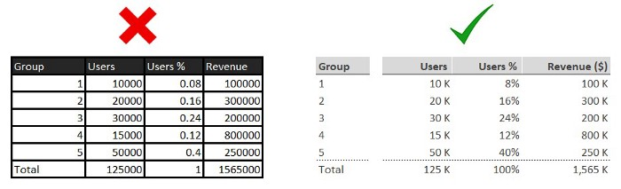

Image by the author

**Charts**

Because they interact with our visual system, a chart will get the point across much quicker and easier than a table. However, they can also be disastrous if overcomplicated. The only purpose of your chart should be to help the audience understand the insight you want to convey. Suppose, on the other hand, the **chart is complicated and requires more effort to understand. In that case, the most likely outcome is that your audience will decide that they don’t want to devote any more time to it and mentally check out** (and understandably so).

* Use titles for your chart
* Use titles for the x-axis and y-axis but deemphasize them with a light color
* Your y-axis should start from 0 to avoid false visual insights
* Avoid using 3d charts as they can skew the visual interpretation and lead to more harm than good
* Use alignment of elements and maintain white space to draw out the pearls
* Remove gridlines
* Use legends to label your data
* Use color and shapes to draw out the insight(s)
* Pick the chart that best showcases your insight(s)

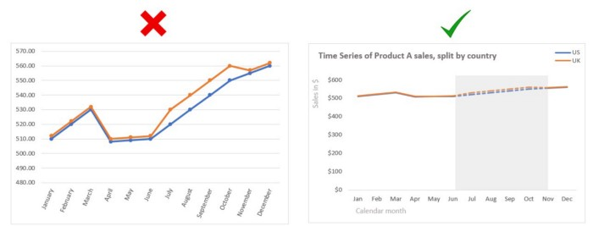

Image by the author

**Summary**

The summary is usually located at the top of your slide. This should be self-explanatory, so the audience understands the insights and how they contribute to your presentation’s primary objective. This can also help you decide on your slide’s effectiveness. If there is no clear summary or it does not provide any incremental information, you might consider changing or even removing the slide.

**3) Fake it until you make it**

This is a standard quote for presenting and public speaking and one that I found most annoying at the beginning of my career. But this was probably the best advice given to me. As with everything else, **the only way to improve is by practicing**.

Similarly to the first time you rode a bike, you weren’t interested in making it on the first try, nor were you so embarrassed by failing that you never tried it. Instead, you first rode a bicycle using helping wheels, and once you felt confident, you started riding without them and kept at it after a couple of falls.

The same principle applies to presenting. You should start with small presentations to make yourself feel more confident and gradually move to bigger audiences. You should also not be afraid to ask for help from others. At the beginning of my career, I would present the decks to myself more than ten times before the actual presentation, and even to this day, I still will do a couple of mock presentations to ensure I feel confident with the flow and structure. Sometimes I also present to my colleagues, which has the benefit of getting a fresh perspective from someone that didn’t spend the last 10+ hours working on the presentation. This is the best way to test whether your deck is of adequate quality and whether its structure and pearls can be clearly understood by someone other than yourself.

**Closing Remarks**

As with good presentations, I wanted to end the article with a quick summary of the above three lessons. I hope they will help you in your journey as they have helped me.

* Your presentations should be simple and structured around your objective and audience (clearly define the who, why and what)
* Use visuals and summaries in your slides to make the insights easier to understand. Any element that doesn’t contribute to that direction should be removed or changed
* Public speaking can be intimidating, but with practice and incremental steps, even the most troubled presenters can become skilled

**Stay in touch**

If you enjoy reading this article and want to learn more, don’t forget to [**subscribe**](https://medium.com/@alex.vamvakaris.ds/subscribe) to get my stories sent directly to your inbox.

On the link below, you can also find a free PDF Walkthrough on completing a Customer Cluster Analysis in a real-life business scenario using data science techniques and best practices in R.